Root Interval Schemas in Rock Music

Jacob Gran and David John Baker

Louisiana State University

South Central Society for Music Theory, March 23-24, 2018

University of Southern Mississippi, Hattiesburg MS

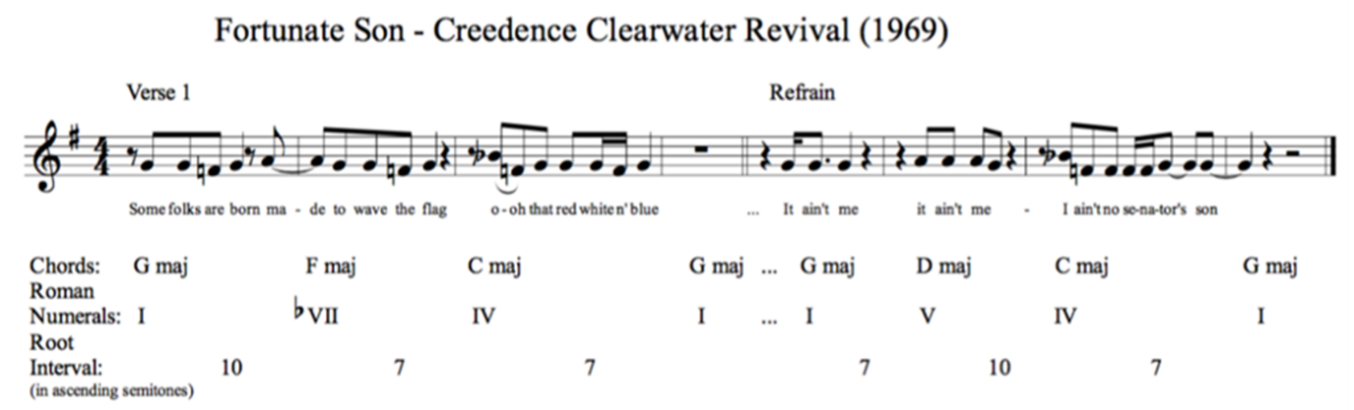

FIGURE 1: Creedence Clearwater Revival, Fortunate Son (1969).

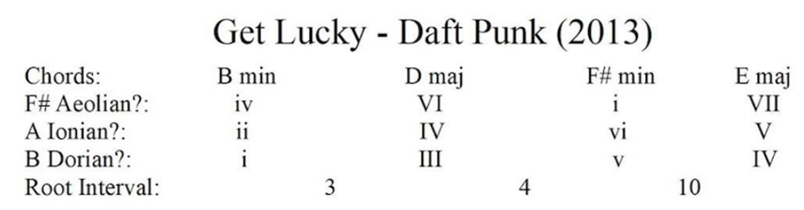

FIGURE 2: Daft Punk featuring Pharell Williams, Get Lucky (2013).

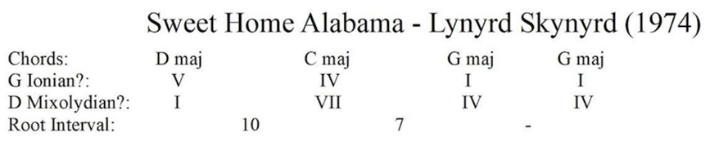

FIGURE 3: Lynyrd Skynyrd, Sweet Home Alabama (1974).

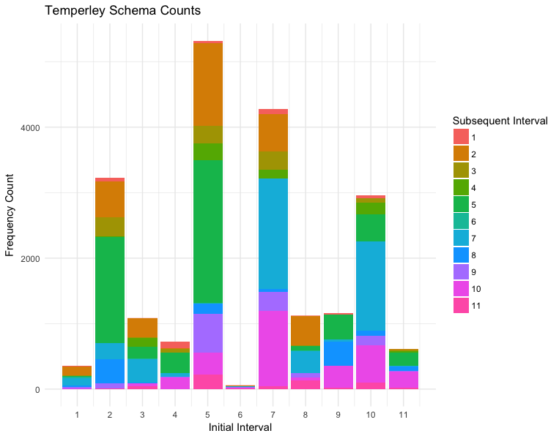

FIGURE 2: RS200 Schema frequency visualization.

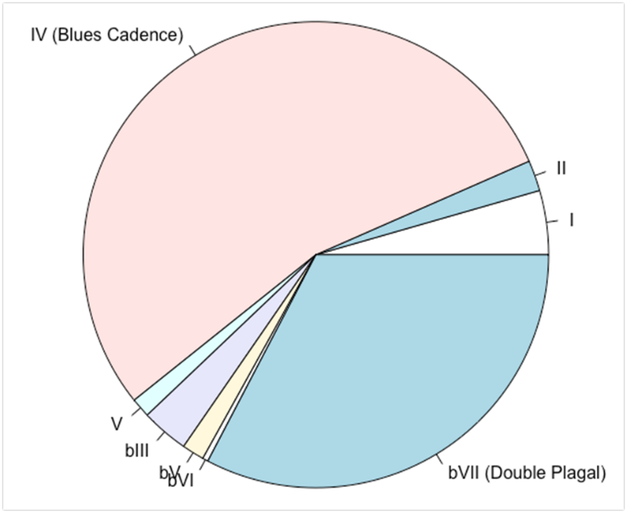

FIGURE 3: 10-7 schema breakdown, comparison of Double Plagal and Blues Cadence versions.

|  |  |
| --- | --- |
| **Schema** | **Count** |
| **5-5** | 2179 |
| **7-7** | 1682 |
| **2-5** | 1618 |
| **10-7** | 1365 |
| **5-2** | 1272 |
| **7-10** | 1148 |
| **5-9** | 595 |
| **7-2** | 573 |
| **10-10** | 565 |

TABLE 1: Most frequent root interval schemas.

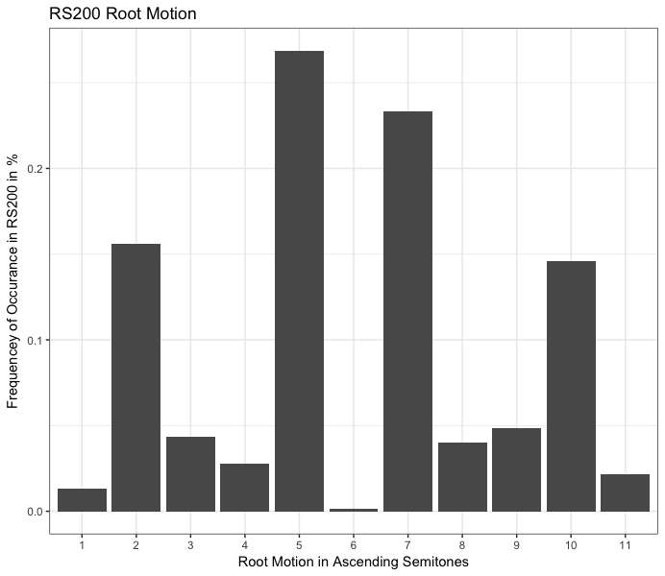

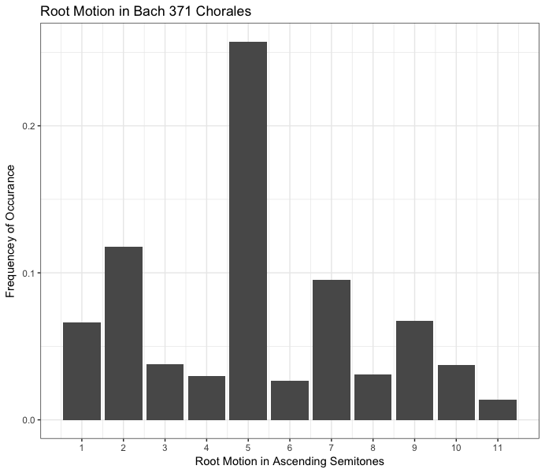

FIGURE 5: Comparison of root interval frequencies in common practice corpus and rock corpus.

Selected Bibliography:

Acevedo, Stefanie. 2018. “Formal and Harmonic Schemata of Popular Music: An Empirical

Investigation of Analytical Patterns and their Mental Representations.” Unpublished doctoral dissertation, Yale University.

Biamonte, Nicole. 2010. “Triadic Modal and Pentatonic Patterns in Rock Music.” *Music Theory*

*Spectrum* 32 no. 2 (Fall): 95-110.

Burgoyne, J.A., Wild, J., and Fujinaga, I. 2011. “An Expert Ground-Truth Set for Audio Chord

Recognition and Music Analysis.” *ISMIR* 2011, 633-638.

De Clercq, Trevor, and David Temperley. 2011. “A Corpus Analysis of Rock Harmony.”

*Popular Music* 30 no. 1: 47- 70.

Hughes, Bryn. 2011. “Harmonic Expectation in Twelve-Bar Blues Progressions.” PhD diss.,

Florida State University.

Nobile, Drew. 2016. “Harmonic Function in Rock Music: A Syntactical Approach.” *Journal of*

*Music Theory* 60 no. 2: 149-180.

Meyer, Leonard B. 1989. *Style and Music: Theory, History, and Ideology*. Philadelphia:

University of Pennsylvania Press.

Saffran, J.R., et al. 1999. “Statistical Learning of Tone Sequences by Human Infants and

Adults.” *Cognition* 70 no. 1: 27-52.

Stephenson, Ken. 2002. *What to Listen for in Rock: A Stylistic Analysis*. New Haven, CT: Yale

University Press.